LEC-30:PYSPARK AGGREAGTION DEEP JOIN
LEFT JOIN
Requirement :Join both the dataframes -take all the ids from the left table and its respective product from the right table.
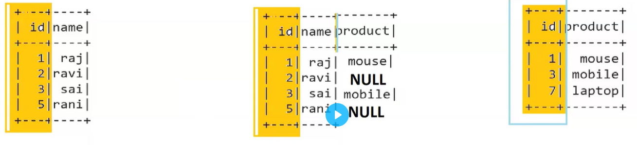
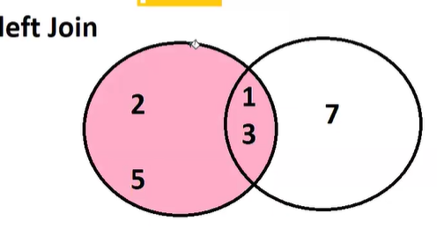
WHENEVER WORKING ON NEW PROJECT :
- Intellij download-------intellij 1.4
- Intellij install----intellij 1.4 open
- installs python plugins----python community editions once installed restart the intellij
- 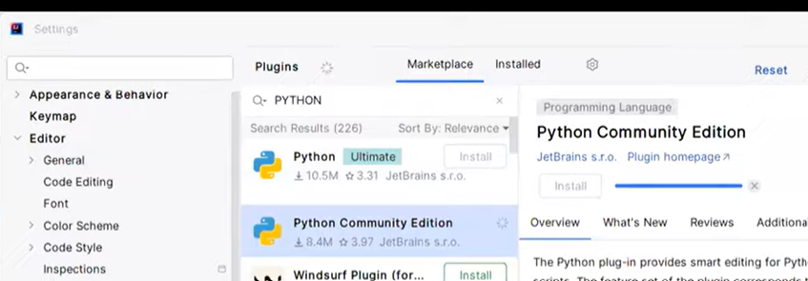
- create python project openintellij->----new project ->name->base interpreter-> python 3.10.11 install
- 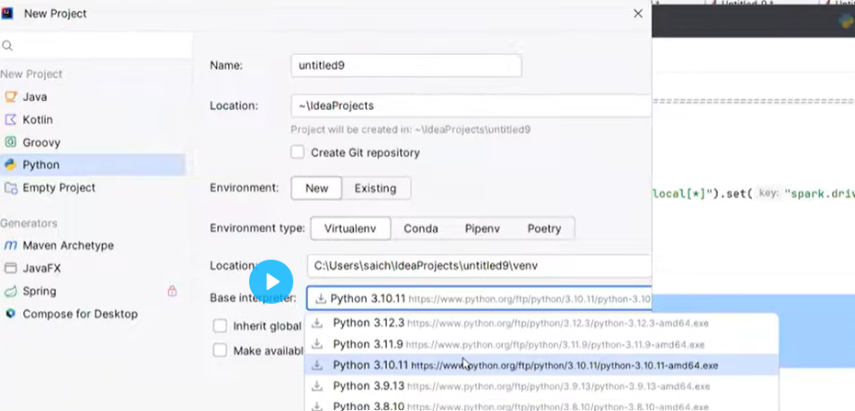
- install pyspark--- go to terminal – write pip install pyspark 3.2.0
- 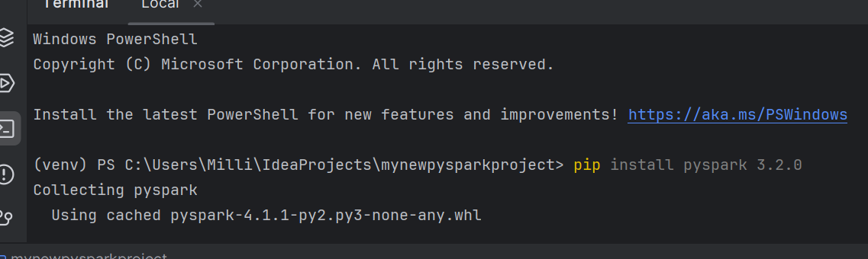
- install jdk---intellij open -> file->project structure->sdk->+->download jdk ->version 1.8->copy path which in location->applied->ok
- create a py file->right click->new->name
- open tinyurl code ----from announcement or common group take the entire code and paste in your pi file.
- Edit the java pathpaste it in py file.
- Pop of allow ok
PRACTICSE 1
INPUT
import os
import sys
from pyspark.sql import SparkSession
from pyspark.sql.functions import expr # ✅ Import expr
# ✅ Force Spark to use your venv Python
os.environ['PYSPARK_PYTHON'] = sys.executable
os.environ['PYSPARK_DRIVER_PYTHON'] = sys.executable
# ✅ Correct JAVA_HOME and PATH
os.environ['JAVA_HOME'] = r'C:\Users\Milli\.jdks\corretto-1.8.0_472'
#C:\Users\Milli\.jdks\corretto-1.8.0_482
os.environ['PATH'] = r'C:\Users\Milli\.jdks\corretto-1.8.0_472\bin' + os.pathsep + os.environ['PATH']
# ================== Spark Setup ==================
spark = SparkSession.builder \
.appName("csv-test") \
.master("local[*]") \
.getOrCreate()
data4 = [
(1, "raj"),
(2, "ravi"),
(3, "sai"),
(5, "rani")
]
cust = spark.createDataFrame(data4, ["id", "name"])
cust.show()
data3 = [
(1, "mouse"),
(3, "mobile"),
(7, "laptop")
]
prod = spark.createDataFrame(data3, ["id", "product"])
prod.show()
print("=====left join=====")
leftjoin = cust. join(prod,["id"],"left")
leftjoin.show()
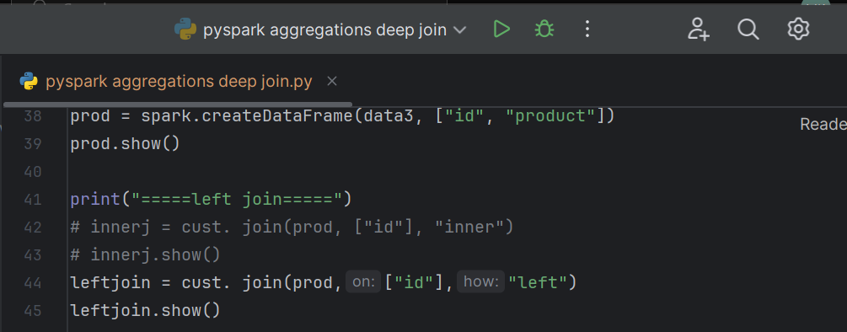
OUTPUT
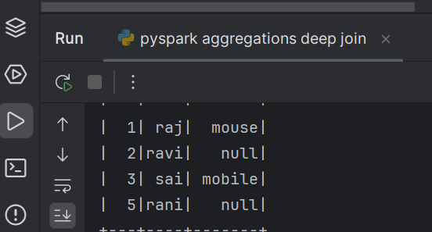
PRACTICSE 2
INPUT
import os
import sys
from pyspark.sql import SparkSession
from pyspark.sql.functions import expr # ✅ Import expr
# ✅ Force Spark to use your venv Python
os.environ['PYSPARK_PYTHON'] = sys.executable
os.environ['PYSPARK_DRIVER_PYTHON'] = sys.executable
# ✅ Correct JAVA_HOME and PATH
os.environ['JAVA_HOME'] = r'C:\Users\Milli\.jdks\corretto-1.8.0_472'
#C:\Users\Milli\.jdks\corretto-1.8.0_482
os.environ['PATH'] = r'C:\Users\Milli\.jdks\corretto-1.8.0_472\bin' + os.pathsep + os.environ['PATH']
# ================== Spark Setup ==================
spark = SparkSession.builder \
.appName("csv-test") \
.master("local[*]") \
.getOrCreate()
data4 = [
(1, "raj"),
(2, "ravi"),
(3, "sai"),
(5, "rani")
]
cust = spark.createDataFrame(data4, ["id", "name"])
cust.show()
data3 = [
(1, "mouse"),
(3, "mobile"),
(7, "laptop")
]
prod = spark.createDataFrame(data3, ["id", "product"])
prod.show()
print("=====left join=====")
leftjoin = cust. join(prod,["id"],"left")
#leftjoin.show()
print("=====left join=====")
leftjoin = cust. join(prod,["id"],"left").orderBy("id")
leftjoin.show()
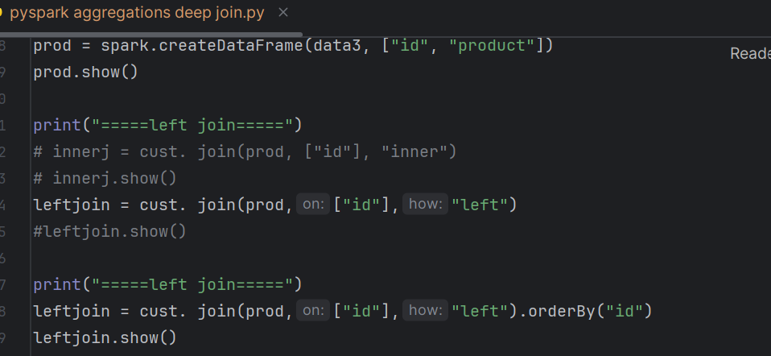
OUTPUT
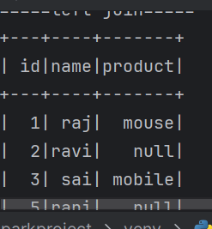

New requirement:Join both dataframes ---take all ids from right table and its respective name from left table
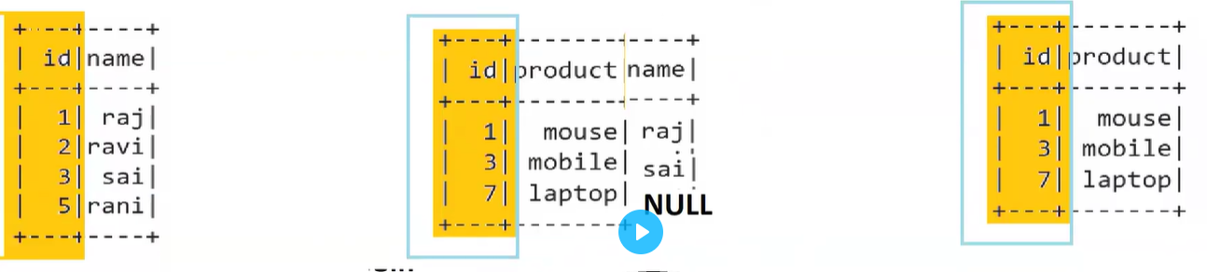
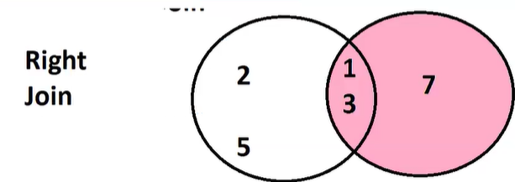

Practicse 3
Input

import os
import sys
from pyspark.sql import SparkSession
from pyspark.sql.functions import expr # ✅ Import expr
# ✅ Force Spark to use your venv Python
os.environ['PYSPARK_PYTHON'] = sys.executable
os.environ['PYSPARK_DRIVER_PYTHON'] = sys.executable
# ✅ Correct JAVA_HOME and PATH
os.environ['JAVA_HOME'] = r'C:\Users\Milli\.jdks\corretto-1.8.0_472'
#C:\Users\Milli\.jdks\corretto-1.8.0_482
os.environ['PATH'] = r'C:\Users\Milli\.jdks\corretto-1.8.0_472\bin' + os.pathsep + os.environ['PATH']
# ================== Spark Setup ==================
spark = SparkSession.builder \
.appName("csv-test") \
.master("local[*]") \
.getOrCreate()
data4 = [
(1, "raj"),
(2, "ravi"),
(3, "sai"),
(5, "rani")
]
cust = spark.createDataFrame(data4, ["id", "name"])
cust.show()
data3 = [
(1, "mouse"),
(3, "mobile"),
(7, "laptop")
]
prod = spark.createDataFrame(data3, ["id", "product"])
prod.show()
print("=====right join=====")
rightjoin = cust. join(prod,["id"],"right").orderBy("id")
rightjoin.show()
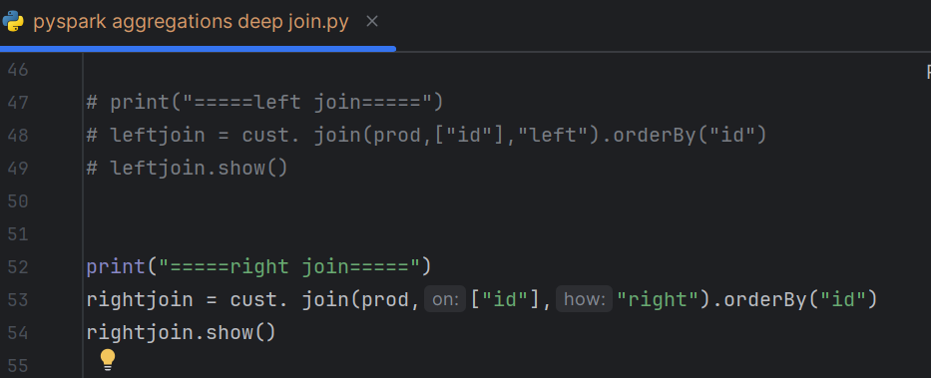

Output
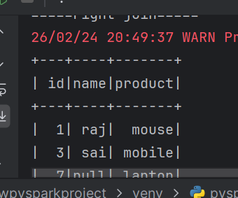
New Requirement:join both dataframes get all ids from left as well as from right dataframe
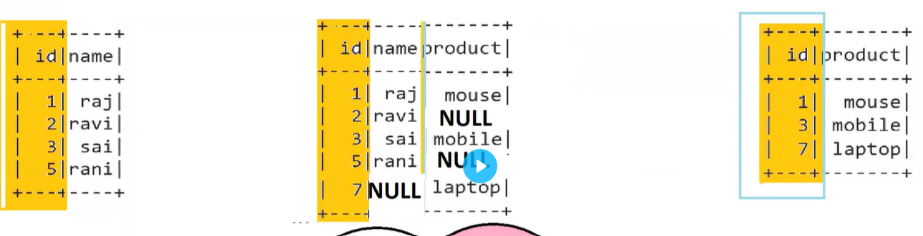
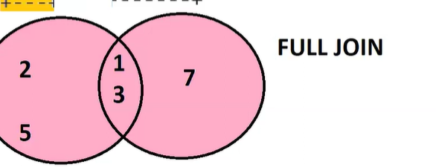
PRACTICSE 4
INPUT
import os
import sys
from pyspark.sql import SparkSession
from pyspark.sql.functions import expr # ✅ Import expr
# ✅ Force Spark to use your venv Python
os.environ['PYSPARK_PYTHON'] = sys.executable
os.environ['PYSPARK_DRIVER_PYTHON'] = sys.executable
# ✅ Correct JAVA_HOME and PATH
os.environ['JAVA_HOME'] = r'C:\Users\Milli\.jdks\corretto-1.8.0_472'
#C:\Users\Milli\.jdks\corretto-1.8.0_482
os.environ['PATH'] = r'C:\Users\Milli\.jdks\corretto-1.8.0_472\bin' + os.pathsep + os.environ['PATH']
# ================== Spark Setup ==================
spark = SparkSession.builder \
.appName("csv-test") \
.master("local[*]") \
.getOrCreate()
data4 = [
(1, "raj"),
(2, "ravi"),
(3, "sai"),
(5, "rani")
]
cust = spark.createDataFrame(data4, ["id", "name"])
cust.show()
data3 = [
(1, "mouse"),
(3, "mobile"),
(7, "laptop")
]
prod = spark.createDataFrame(data3, ["id", "product"])
prod.show()
print("=====FULL join=====")
fulljoin = cust. join(prod,["id"],"full").orderBy("id")
fulljoin.show()
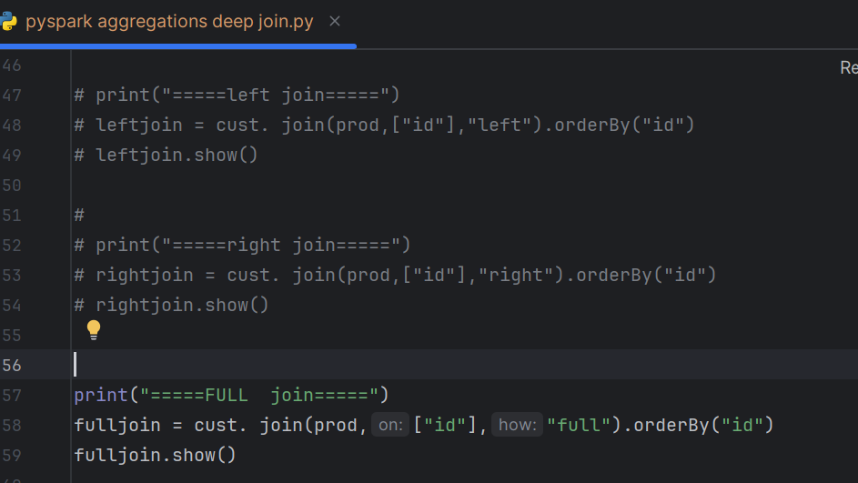
OUTPUT
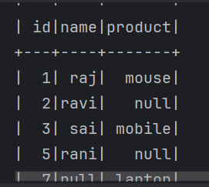
PRACTICSE 5
INPUT
import os
import sys
from pyspark.sql import SparkSession
from pyspark.sql.functions import expr # ✅ Import expr
# ✅ Force Spark to use your venv Python
os.environ['PYSPARK_PYTHON'] = sys.executable
os.environ['PYSPARK_DRIVER_PYTHON'] = sys.executable
# ✅ Correct JAVA_HOME and PATH
os.environ['JAVA_HOME'] = r'C:\Users\Milli\.jdks\corretto-1.8.0_472'
#C:\Users\Milli\.jdks\corretto-1.8.0_482
os.environ['PATH'] = r'C:\Users\Milli\.jdks\corretto-1.8.0_472\bin' + os.pathsep + os.environ['PATH']
# ================== Spark Setup ==================
spark = SparkSession.builder \
.appName("csv-test") \
.master("local[*]") \
.getOrCreate()
data4 = [
(1, "raj"),
(2, "ravi"),
(3, "sai"),
(5, "rani")
]
cust = spark.createDataFrame(data4, ["id", "name"])
cust.show()
data3 = [
(1, "mouse"),
(3, "mobile"),
(7, "laptop")
]
prod = spark.createDataFrame(data3, ["Cid", "product"])
prod.show()
print("=====INNER join=====")
joindf= cust. join(prod,cust["id"]==prod ["cid"], "inner")
#joindf= cust. join(prod,cust["id"]==prod ["cid"], "inner").drop("cid")
joindf.show()
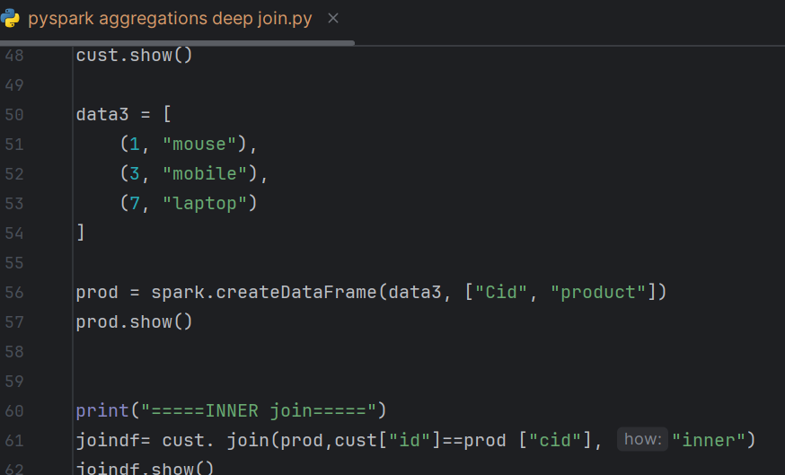
OUTPUT
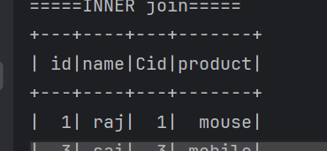
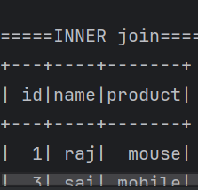
PRACTICSE 6
INPUT
import os
import sys
from pyspark.sql import SparkSession
from pyspark.sql.functions import expr # ✅ Import expr
# ✅ Force Spark to use your venv Python
os.environ['PYSPARK_PYTHON'] = sys.executable
os.environ['PYSPARK_DRIVER_PYTHON'] = sys.executable
# ✅ Correct JAVA_HOME and PATH
os.environ['JAVA_HOME'] = r'C:\Users\Milli\.jdks\corretto-1.8.0_472'
#C:\Users\Milli\.jdks\corretto-1.8.0_482
os.environ['PATH'] = r'C:\Users\Milli\.jdks\corretto-1.8.0_472\bin' + os.pathsep + os.environ['PATH']
# ================== Spark Setup ==================
spark = SparkSession.builder \
.appName("csv-test") \
.master("local[*]") \
.getOrCreate()
data4 = [
(1, "raj"),
(2, "ravi"),
(3, "sai"),
(5, "rani")
]
cust = spark.createDataFrame(data4, ["id", "name"])
cust.show()
data3 = [
(1, "mouse"),
(3, "mobile"),
(7, "laptop")
]
prod = spark.createDataFrame(data3, ["Cid", "product"])
prod.show()
print("=====FULL join=====")
joindf= cust. join(prod,cust["id"]==prod ["cid"], "full")
joindf.show()
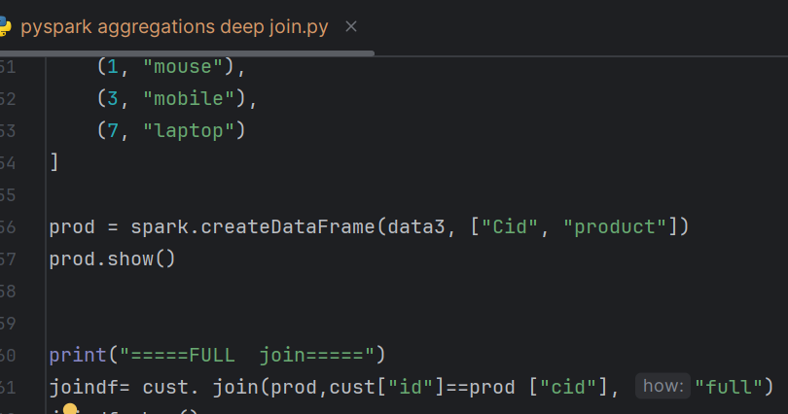
OUTPUT
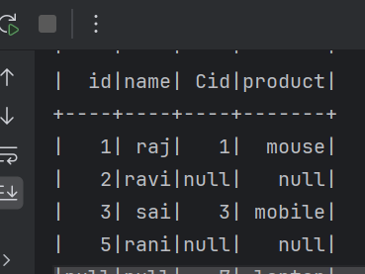
Practices 7
Input
import os
import sys
from pyspark.sql import SparkSession
from pyspark.sql.functions import expr # ✅ Import expr
# ✅ Force Spark to use your venv Python
os.environ['PYSPARK_PYTHON'] = sys.executable
os.environ['PYSPARK_DRIVER_PYTHON'] = sys.executable
# ✅ Correct JAVA_HOME and PATH
os.environ['JAVA_HOME'] = r'C:\Users\Milli\.jdks\corretto-1.8.0_472'
#C:\Users\Milli\.jdks\corretto-1.8.0_482
os.environ['PATH'] = r'C:\Users\Milli\.jdks\corretto-1.8.0_472\bin' + os.pathsep + os.environ['PATH']
# ================== Spark Setup ==================
spark = SparkSession.builder \
.appName("csv-test") \
.master("local[*]") \
.getOrCreate()
data4 = [
(1, "raj"),
(2, "ravi"),
(3, "sai"),
(5, "rani")
]
cust = spark.createDataFrame(data4, ["id", "name"])
cust.show()
data3 = [
(1, "mouse"),
(3, "mobile"),
(7, "laptop")
]
prod = spark.createDataFrame(data3, ["Cid", "product"])
prod.show()
print("=====FULL join=====")
fulldf= cust. join(prod,cust["id"]==prod ["cid"], "full")
fulldf.show()
finaldf=(
fulldf.withColumn("id",expr("case when id is null then cid else id end"))
)
finaldf.show()
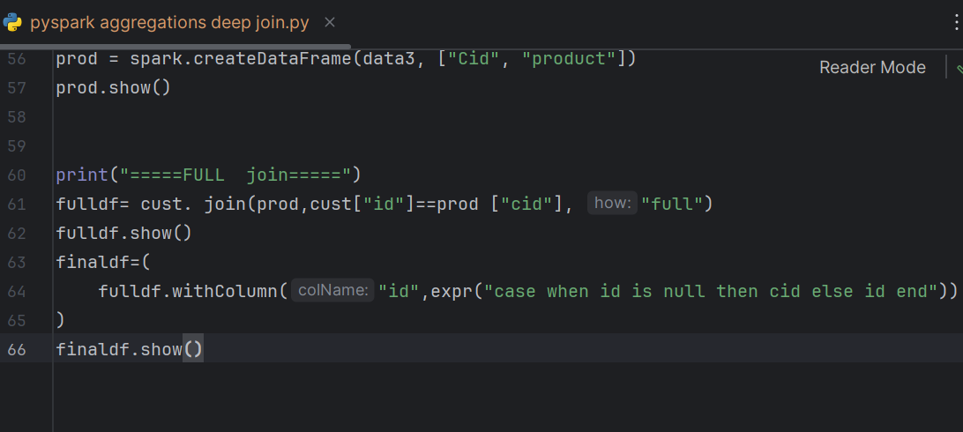
OUTPUT
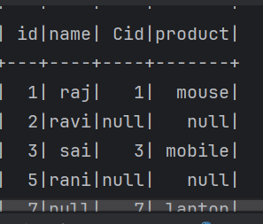
PRACTICSE 7
INPUT
import os
import sys
from pyspark.sql import SparkSession
from pyspark.sql.functions import expr # ✅ Import expr
# ✅ Force Spark to use your venv Python
os.environ['PYSPARK_PYTHON'] = sys.executable
os.environ['PYSPARK_DRIVER_PYTHON'] = sys.executable
# ✅ Correct JAVA_HOME and PATH
os.environ['JAVA_HOME'] = r'C:\Users\Milli\.jdks\corretto-1.8.0_472'
#C:\Users\Milli\.jdks\corretto-1.8.0_482
os.environ['PATH'] = r'C:\Users\Milli\.jdks\corretto-1.8.0_472\bin' + os.pathsep + os.environ['PATH']
# ================== Spark Setup ==================
spark = SparkSession.builder \
.appName("csv-test") \
.master("local[*]") \
.getOrCreate()
data4 = [
(1, "raj"),
(2, "ravi"),
(3, "sai"),
(5, "rani")
]
cust = spark.createDataFrame(data4, ["id", "name"])
cust.show()
data3 = [
(1, "mouse"),
(3, "mobile"),
(7, "laptop")
]
prod = spark.createDataFrame(data3, ["Cid", "product"])
prod.show()
print("=====FULL join=====")
fulldf= cust. join(prod,cust["id"]==prod ["cid"], "full")
fulldf.show()
finaldf=(
fulldf.withColumn("id",expr("coalesce(id,cid) "))
)
finaldf.show()
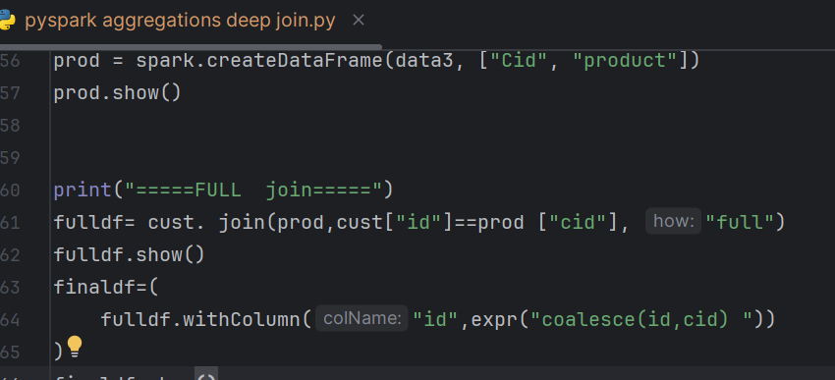
Output
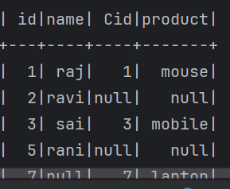
New Requirement:
Join both the dataframes ,get the ids from the left table which does not present in the right table
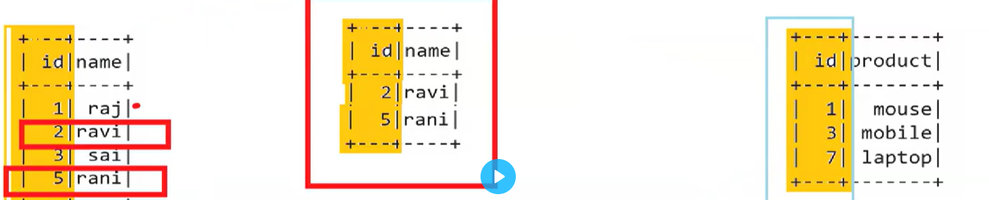
PRACTICSE 8
import os
import sys
from pyspark.sql import SparkSession
from pyspark.sql.functions import expr # ✅ Import expr
# ✅ Force Spark to use your venv Python
os.environ['PYSPARK_PYTHON'] = sys.executable
os.environ['PYSPARK_DRIVER_PYTHON'] = sys.executable
# ✅ Correct JAVA_HOME and PATH
os.environ['JAVA_HOME'] = r'C:\Users\Milli\.jdks\corretto-1.8.0_472'
#C:\Users\Milli\.jdks\corretto-1.8.0_482
os.environ['PATH'] = r'C:\Users\Milli\.jdks\corretto-1.8.0_472\bin' + os.pathsep + os.environ['PATH']
# ================== Spark Setup ==================
spark = SparkSession.builder \
.appName("csv-test") \
.master("local[*]") \
.getOrCreate()
data4 = [
(1, "raj"),
(2, "ravi"),
(3, "sai"),
(5, "rani")
]
cust = spark.createDataFrame(data4, ["id", "name"])
cust.show()
data3 = [
(1, "mouse"),
(3, "mobile"),
(7, "laptop")
]
prod = spark.createDataFrame(data3, ["id", "product"])
prod.show()
leftAnti=cust.join(prod,["id"],"leftanti")
leftAnti.show()
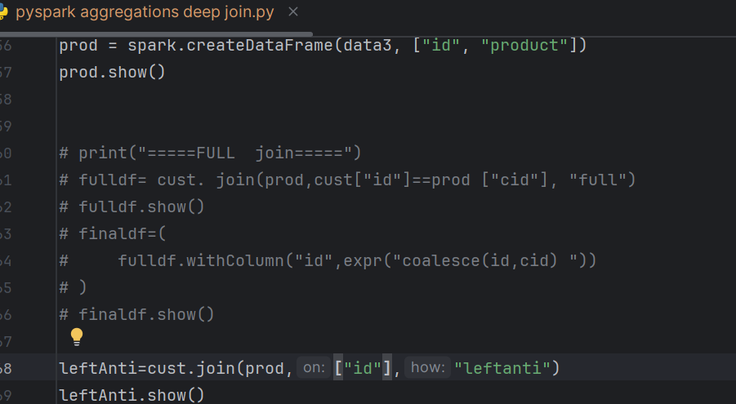
OUTPUT
